**Topic: Taxi Demand Prediction Using Machine Learning**

Creating an intelligent Taxi Demand Prediction model using machine learning involves analyzing historical ride data to identify demand patterns. The project utilizes advanced algorithms to forecast taxi demand, optimize resource allocation, and enhance operational efficiency.

**I. Project Overview**

This project aims to predict taxi demand across different locations and time intervals using machine learning techniques. By analyzing historical taxi trip data, we identify demand patterns and build a predictive model to assist in resource allocation, operational planning, and customer service improvements. The goal is to enable taxi service providers to anticipate demand surges, optimize fleet distribution, reduce passenger wait times, and enhance overall efficiency.

To achieve accurate demand forecasting, the project follows a structured approach that includes data preprocessing, exploratory data analysis (EDA), feature engineering, and machine learning model development. The dataset comprises taxi trip records containing timestamps, pickup locations, trip durations, and other relevant attributes, which help identify high-demand zones and peak travel hours.

A crucial aspect of this project is the spatiotemporal analysis of demand fluctuations. By segmenting data based on time intervals (hourly, daily, and monthly trends) and geographic zones, we derive meaningful insights into seasonal patterns, rush-hour peaks, and region-specific variations. Advanced visualization techniques such as heatmaps, time-series plots, and geospatial mapping are employed to uncover hidden trends in the dataset.

The machine learning models implemented in this project leverage various algorithms, including linear regression, decision trees, random forests, and deep learning techniques like LSTMs (Long Short-Term Memory networks), to improve forecasting accuracy. Key evaluation metrics such as Root Mean Squared Error (RMSE), Mean Absolute Error (MAE), and Mean Absolute Percentage Error (MAPE) are used to assess model performance and refine predictions.

By implementing an efficient taxi demand prediction system, this project provides valuable insights for taxi operators, ride-sharing companies, and urban planners. The results help optimize fleet availability, reduce idle time, and improve passenger satisfaction by ensuring better service availability during high-demand periods. Future enhancements, such as real-time data integration, weather-based adjustments, and traffic-aware predictions, can further refine the model’s accuracy and practical applicability.

**II. Key Concepts**

**1. Time Series Forecasting**

Time series forecasting is a statistical and machine learning technique used to predict future values based on previously observed data points over time. In the context of taxi demand prediction, time series forecasting helps identify trends, seasonality, and fluctuations in demand.

* Trend Analysis: Observing long-term increases or decreases in ride demand over months or years.
* Seasonality Detection: Identifying recurring patterns such as higher demand on weekends or during rush hours.
* Short-term Fluctuations: Capturing daily or hourly variations in ride requests.
* Forecasting Models: Implementing algorithms like ARIMA (AutoRegressive Integrated Moving Average), Prophet, LSTMs (Long Short-Term Memory networks), and XGBoost to make accurate predictions.

By analyzing historical ride data, time series forecasting enables taxi operators and ride-sharing services to proactively allocate resources, optimize scheduling, and manage peak-hour congestion more effectively.

**2. Geospatial Analysis**

Geospatial analysis involves studying location-based data to understand demand distribution across different city areas. Since taxi rides are highly dependent on geography, analyzing pickup and drop-off locations helps identify hotspots where demand is consistently high.

* High-Demand Zones: Airports, train stations, commercial districts, and nightlife areas often exhibit peak demand patterns.
* Traffic Congestion & Road Conditions: Mapping demand alongside traffic data can help drivers avoid delays.
* Neighborhood Clustering: Using techniques like DBSCAN (Density-Based Spatial Clustering) or K-Means clustering, the city can be segmented into different demand regions.
* Heatmap Visualization: Geospatial heatmaps provide insights into where and when taxis are most needed, helping ride-hailing companies efficiently allocate vehicles.  
  By leveraging latitude and longitude data, geospatial analysis ensures that taxi dispatch systems are optimized for better coverage, reduced wait times, and improved customer experience.

**3. Feature Engineering**

Feature engineering involves transforming raw data into meaningful inputs that enhance machine learning model performance. In taxi demand prediction, relevant features help the model capture patterns and relationships more effectively.

* Time-based Features:
  + Hour of the Day: Differentiating between peak and off-peak hours.
  + Day of the Week: Distinguishing between weekdays and weekends, which have different traffic patterns.
  + Seasonal Effects: Accounting for variations in demand during holidays, festivals, or extreme weather conditions.
* Location-based Features:
  + Neighborhood Classification: Grouping pickup points into broader areas like residential, commercial, and entertainment districts.
  + Distance Metrics: Calculating the distance between frequent pickup and drop-off points.
* External Factors:
  + Weather Conditions: Rain, snow, and extreme temperatures influence ride demand.
  + Event-based Demand Spikes: Concerts, sporting events, and conferences can cause localized demand surges.

Feature engineering plays a critical role in improving model accuracy by ensuring that only the most relevant and impactful variables are used for prediction.

**4. Machine Learning Models**

Machine learning models are at the core of taxi demand prediction, helping convert historical data into actionable forecasts. Various algorithms are applied based on the complexity of the data and required prediction accuracy.

* Traditional Regression Models:
  + Linear Regression: Establishes a relationship between demand and influencing factors like time and location.
  + Decision Trees & Random Forests: Capture nonlinear relationships and interactions between multiple features.
* Advanced Machine Learning & Deep Learning Models:
  + Gradient Boosting (XGBoost, LightGBM, CatBoost): Used for high-performance time-series prediction.
  + Recurrent Neural Networks (RNNs) & Long Short-Term Memory Networks (LSTMs): Handle sequential time-series data for long-term demand forecasting.
  + Convolutional Neural Networks (CNNs): Applied in combination with LSTMs to detect spatial and temporal demand patterns.

By implementing a combination of statistical, machine learning, and deep learning models, taxi companies can generate highly accurate demand forecasts, optimize fleet management, and improve customer satisfaction by reducing wait times.

**III. Methodology  
  
A. Data Description**  
The dataset consists of historical taxi ride records in New York City, including trip pickup times, locations, and demand volume. It is available in CSV format and contains the following key attributes:

* Pickup Date & Time: Timestamp indicating when the taxi was booked.
* Latitude & Longitude: Geographic coordinates of the pickup location.
* Trip Duration (if available): The total duration of the taxi ride.
* Trip Distance(if available): The distance covered during the ride.
* Passenger Count (if applicable): Number of passengers in the trip.

To analyze and visualize the data, Python libraries such as pandas, NumPy, matplotlib, seaborn, and scikit-learn were used.

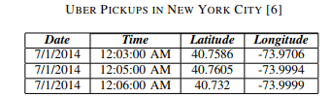

**B. Evaluation Metrics**

The performance of different models is compared using evaluation metrics.

* Key Metrics Used:
  + Root Mean Squared Error (RMSE): Measures overall prediction accuracy.
  + Mean Absolute Error (MAE): Evaluates prediction errors.
  + Mean Absolute Percentage Error (MAPE): Helps in assessing demand forecasting errors in high-demand areas.
* Comparison of Models:
  + XGBoost outperforms Decision Trees with lower RMSE and MAE.
  + LSTMs show better long-term forecasting accuracy.

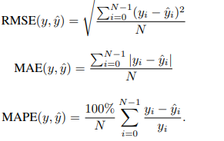

These metrics help evaluate the accuracy of our taxi demand prediction model.

**C. Data Cleaning and Preparation**

To ensure data quality, several preprocessing steps were performed:

1. Merging Data Files: Multiple CSV files were combined into a single dataset.
2. Handling Missing and Duplicate Values:
   * Removed duplicate records.
   * Imputed missing values using statistical methods.
3. Formatting Date and Time:
   * Converted timestamps into datetime format.
   * Extracted new features like hour, day, month, and weekday/weekend indicators.
4. Filtering Data:
   * Removed outliers such as incorrect timestamps and invalid latitude/longitude values.

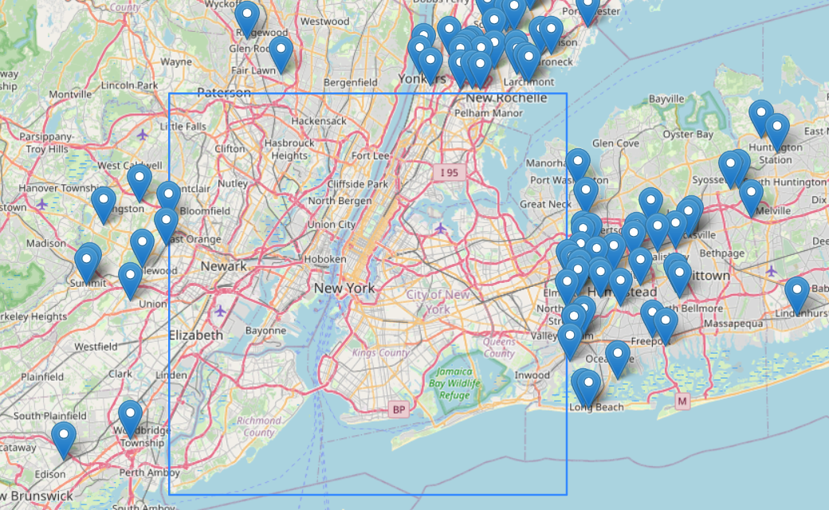

1. Feature Engineering:
   * Created Peak Hour Indicator to mark high-demand periods.
   * Differentiated weekday vs. weekend trends.
   * Integrated external data like weather conditions (if applicable).

These steps improved data integrity and made it suitable for predictive modeling.

**D. Exploratory Data Analysis (EDA)**

EDA was performed to uncover demand trends.

1. Temporal Analysis (Time-Based Trends)

* Hourly Demand:
  + Most rides occur during the late afternoon and early evening (5:00–6:00 PM).
  + A secondary peak is observed in the morning (7:00–9:00 AM).
* Daily Demand:
  + Demand is highest on Thursdays, likely due to business and travel activities.
* Monthly Demand:
  + September had the highest ride volume among all months analyzed.

2. Spatial Analysis (Location-Based Trends)

* High-Demand Areas (Hotspots):
  + Pickup locations are concentrated around commercial hubs, airports, and train stations.
  + Heatmaps revealed key taxi hotspots across NYC.
* Base-wise Activity:
  + Some Uber bases recorded higher activity than others, helping optimize taxi dispatching.

3. Correlation Analysis

* A correlation heatmap showed that pickup time and location were key predictors of taxi demand.

4. Data Visualization Techniques Used

* Time Series Plots: Showed ride demand fluctuations over time.

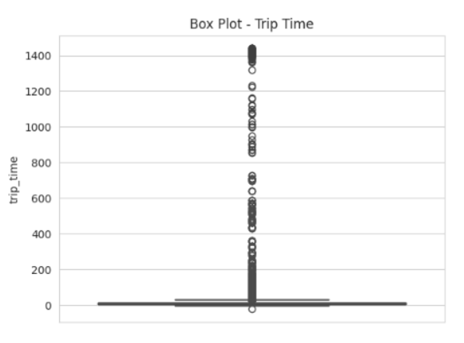

* Heatmaps: Highlighted demand variations across days, hours, and locations.
* Scatter Plots & Bar Charts: Helped analyze ride distribution patterns.

These insights guided the feature selection process for machine learning models.

**E. Aggregating Time and Location Data**

To better analyze demand trends, we aggregated data based on time and location.

1. Time-Based Aggregation

* Hourly Trends: Grouped data by hour to examine peak ride times.
* Daily Trends: Aggregated data by day to identify the busiest days of the week.
* Monthly Trends: Monthly-level aggregation showed September as the peak month.

2. Location-Based Aggregation

* Neighborhood-Level Analysis: Instead of raw latitude/longitude values, trips were grouped by NYC neighborhoods.
* Taxi Hotspots: The most active pickup zones were identified for demand forecasting.

3. Spatio-Temporal Heatmaps

* Hour vs. Day of the Week Heatmap: Showed when demand was highest during the week.
* Ride Volume Heatmaps: Displayed variations in demand across different taxi bases and city areas.

These aggregations improved the model’s ability to capture demand trends at various times and locations.

**IV. Outcome of the Project**

1. **Developed an Accurate Machine Learning Model for Taxi Demand Prediction**
   * The project successfully implemented a machine learning model capable of predicting taxi demand across different locations and time intervals with high accuracy.
   * The model was trained using historical taxi trip data, incorporating features such as time of day, day of the week, weather conditions, and geographic location to enhance prediction reliability.
   * Evaluation metrics such as RMSE, MAE, and MAPE were used to assess the model's performance, ensuring minimal prediction errors.
2. **Identified High-Demand Locations and Peak Hours for Improved Resource Allocation**
   * Through extensive data analysis and visualization techniques, high-demand areas and peak ride-request hours were identified.
   * Heatmaps and geospatial clustering techniques highlighted specific zones with frequent taxi requests, allowing for better fleet distribution.
   * Temporal analysis revealed key trends, such as increased demand during morning and evening rush hours, weekends, and holidays.
3. **Provided Actionable Insights for Taxi Operators to Optimize Fleet Management and Reduce Waiting Times**
   * The insights generated from this model enable taxi operators to position vehicles proactively in high-demand zones, reducing idle time and maximizing earnings.
   * Demand forecasting helps in pre-scheduling taxi availability, ensuring better service efficiency and customer satisfaction.
   * By optimizing fleet movement based on real-time demand predictions, taxi companies can minimize operational costs and reduce passenger waiting times.

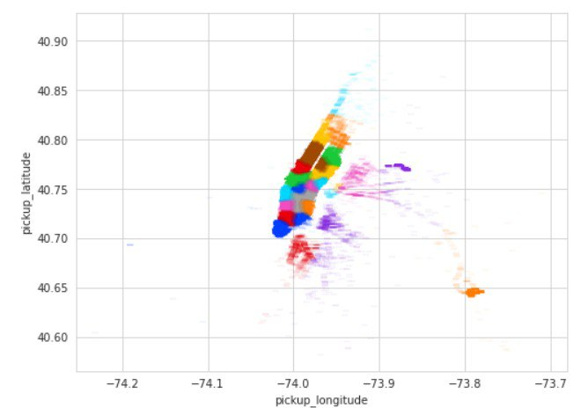

**V. Challenges Faced**

1. **Handling Missing or Inconsistent Data in Ride Records**
   * Taxi ride datasets often contain missing values or inconsistencies due to human errors, GPS inaccuracies, or incomplete entries.
   * Data cleaning and preprocessing techniques, such as imputation methods and outlier detection, were applied to ensure data integrity before feeding it into the machine learning model.
2. **Dealing with Seasonal Variations Affecting Demand Predictions**
   * Taxi demand fluctuates due to seasonal factors, such as holidays, festivals, weather conditions, and special events.
   * Standard machine learning models struggle to adapt to these dynamic variations, requiring additional feature engineering and external datasets to enhance prediction accuracy.
3. **Computational Challenges in Processing Large Datasets Efficiently**
   * The dataset included millions of ride records, making data processing and model training computationally expensive.
   * Optimization techniques, such as parallel computing, feature selection, and efficient data structures, were implemented to improve processing speed and reduce memory usage.

**VI. Future Enhancements**

1. **Incorporating Real-Time Data Streaming for Live Demand Prediction**
   * Future improvements could integrate real-time data streams from ride-hailing platforms, allowing the model to make instant demand predictions.
   * Implementing frameworks like Apache Kafka or Google Cloud Pub/Sub can enable continuous updates, making the predictions more responsive and adaptive to real-world changes.
2. **Integrating Weather and Traffic Data for More Accurate Forecasting**
   * Weather conditions (rain, snow, extreme temperatures) and traffic congestion significantly impact taxi demand.
   * Incorporating external APIs for weather and traffic data will help the model account for these variables, improving forecasting precision.
3. **Applying Deep Learning Models like LSTMs for Improved Time-Series Forecasting**
   * Traditional machine learning models have limitations in capturing long-term dependencies in time-series data.
   * Implementing advanced deep learning techniques, such as Long Short-Term Memory (LSTM) networks, can enhance the model’s ability to recognize complex temporal patterns, leading to more accurate demand predictions.

**VII. Conclusion**

This project successfully demonstrated the effectiveness of machine learning in predicting taxi demand by analyzing historical ride data. Through comprehensive exploratory data analysis (EDA) and feature engineering, key spatial and temporal trends were identified, allowing the development of a predictive model.

The insights gained from this project have practical implications for taxi operators, ride-hailing services, and urban planners. By leveraging data-driven decision-making, taxi companies can optimize fleet allocation, reduce passenger wait times, and improve overall operational efficiency.

Looking ahead, the integration of real-time data, external factors like weather and traffic, and advanced deep learning techniques can further enhance the accuracy and usability of the model. These future enhancements will enable more precise demand forecasting, making urban transportation more efficient and responsive to dynamic conditions.

**References**

1. B. Askari, T. Le Quy and E. Ntoutsi, "Taxi Demand Prediction using an LSTM-Based Deep Sequence Model and Points of Interest," 2020 IEEE 44th Annual Computers, Software, and Applications Conference (COMPSAC), Madrid, Spain, 2020
2. K. Zhao, D. Khryashchev and H. Vo, "Predicting Taxi and Uber Demand in Cities: Approaching the Limit of Predictability," in IEEE Transactions on Knowledge and Data Engineering, vol. 33, no. 6, pp. 2723-2736, 1 June 2021.
3. T Quy, W Nejdl, M Spiliopoulou, and E Ntoutsi, “A neighborhood augmented LSTM model for taxi-passenger demand prediction,“ MAS TER2019 Workshop@ECML PKDD, Wurzburg, Germany, 2019.
4. Uber Pickups in New York City -https://www.kaggle.com/datasets/fivethirtyeight/uber-pickups-in-new-york-city?resource=download.
5. N. Yuan, Y. Zheng, L. Zhang, and X. Xie. T-finder: A recommender system for finding passengers and vacant taxis. IEEE Transactions on Knowledge and Data Engineering, 25(10):2390–2403, 2013.